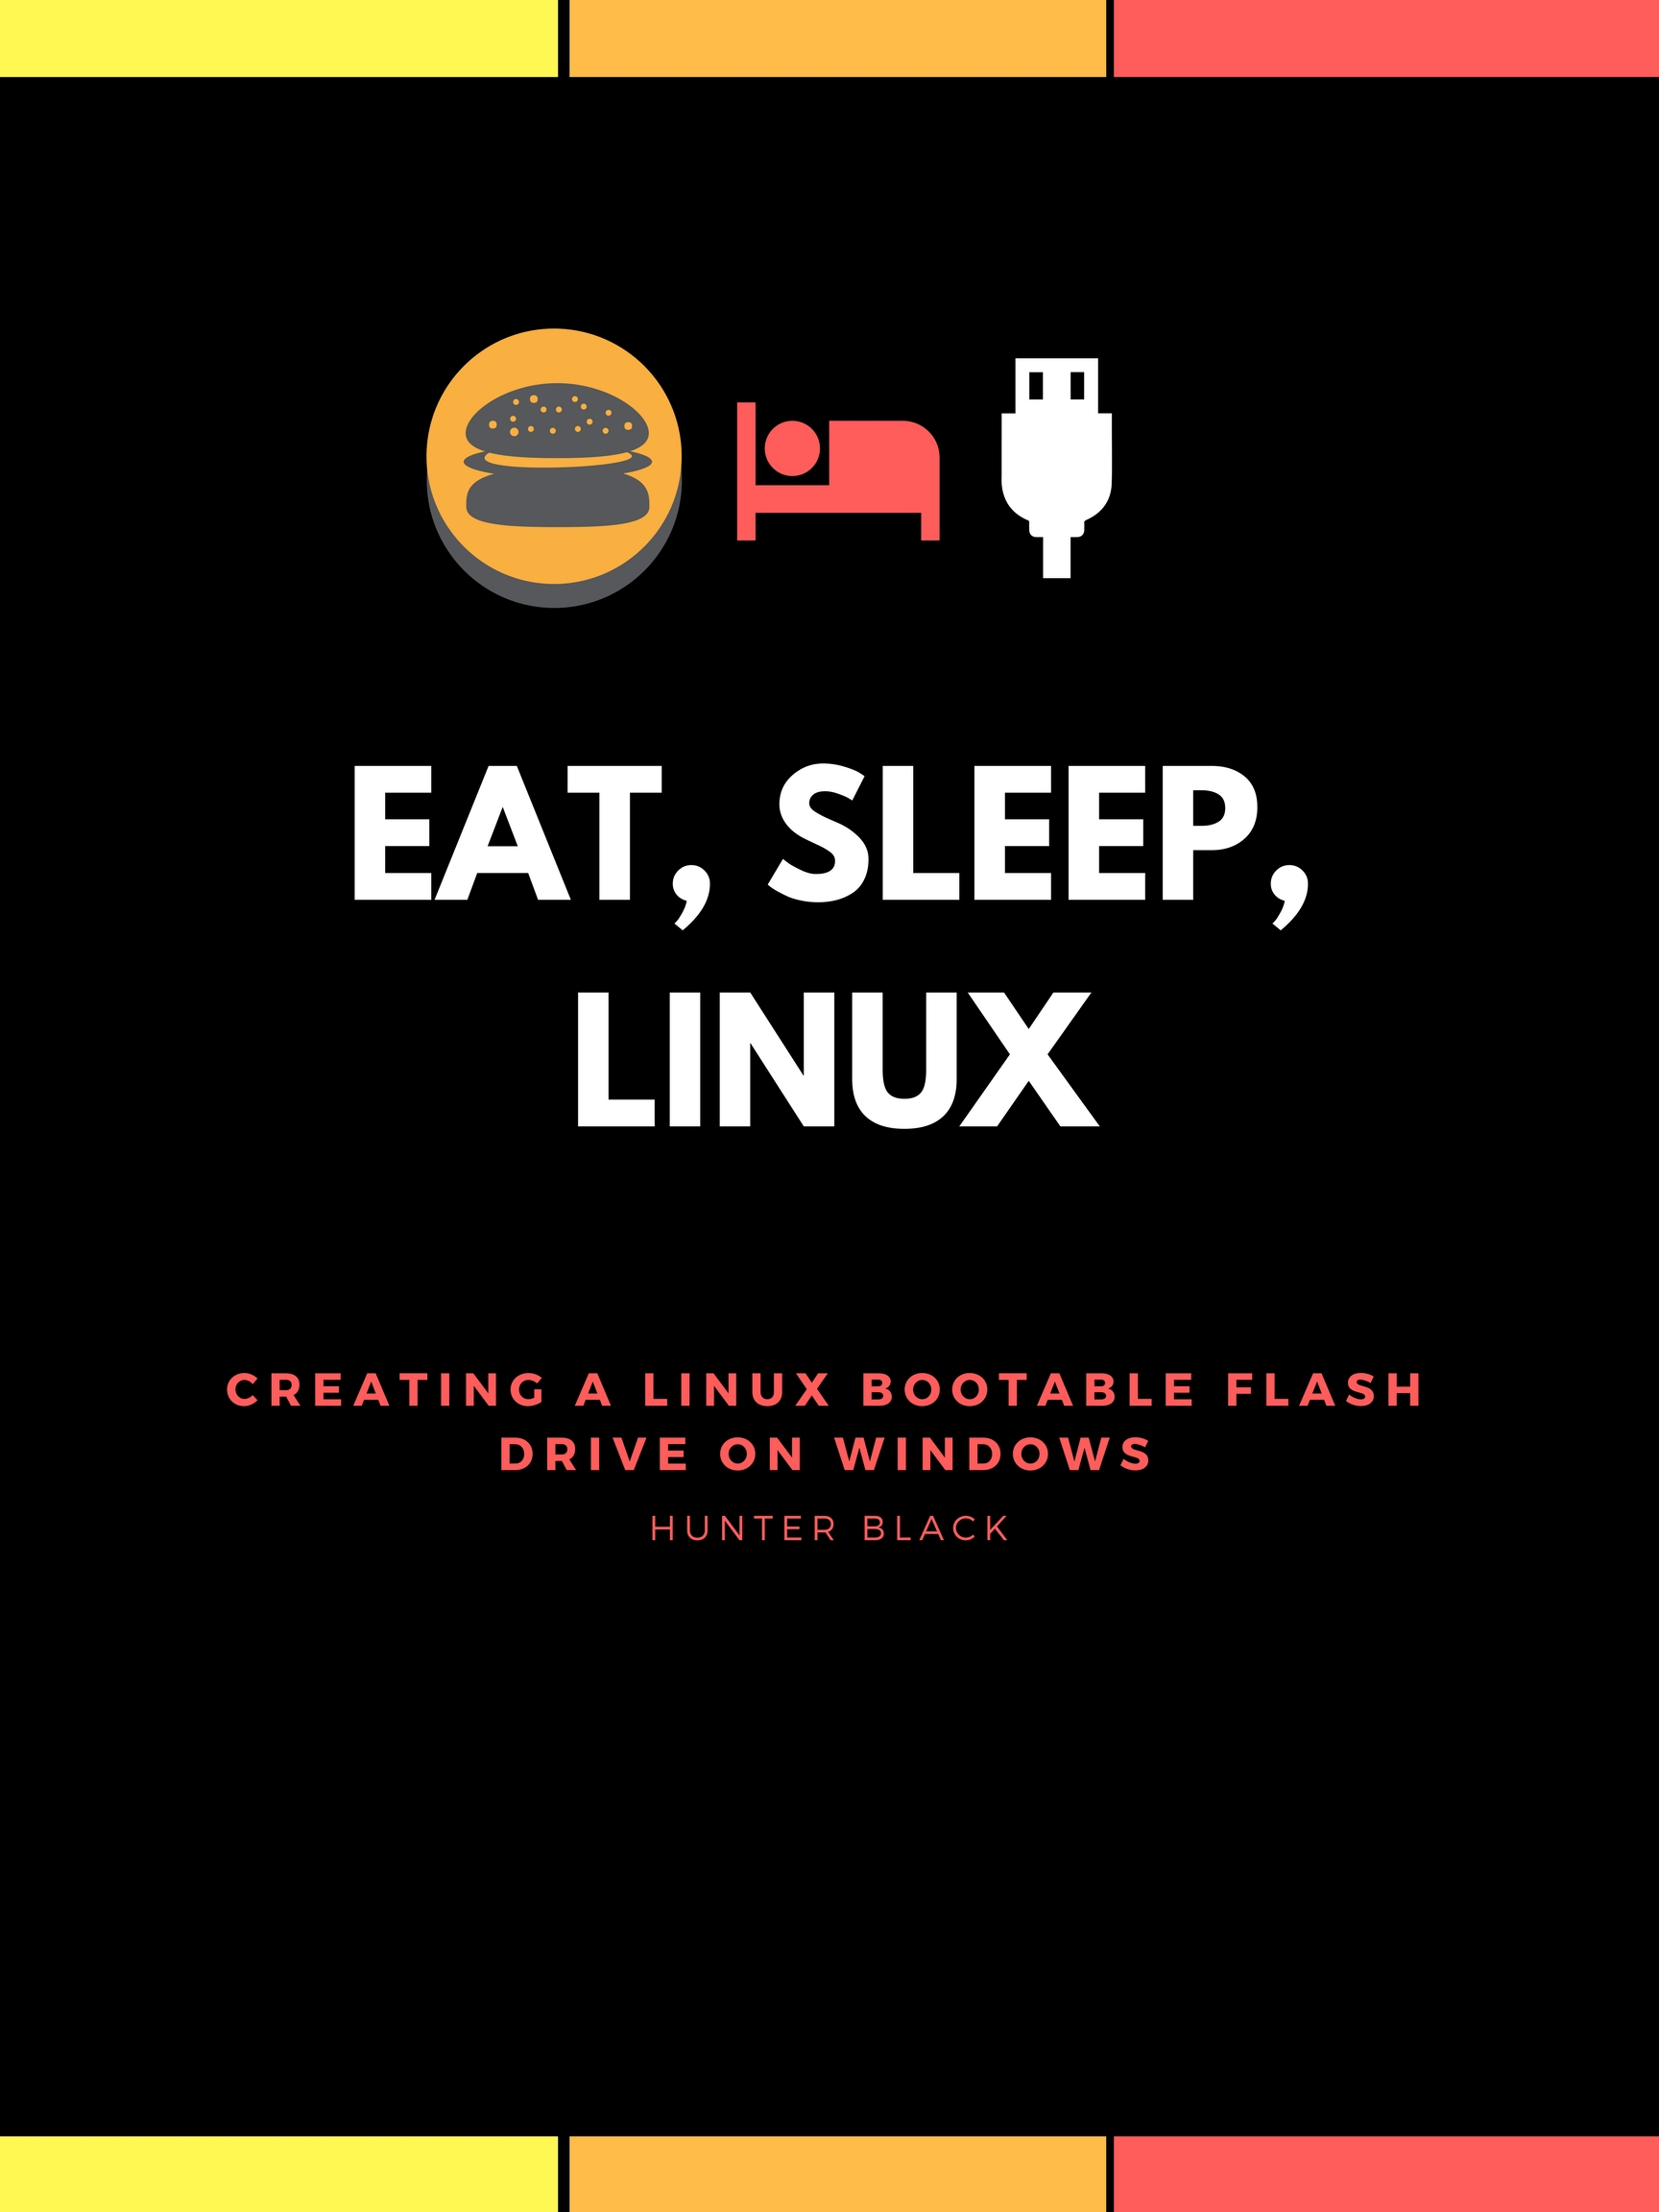

**Introduction**

What is Linux?

Linux, just like Windows or MacOS, is an operating system. It is an environment that allows computer users to interact with their computer and perform basic functions without having to have extensive knowledge of how computers work. Unlike other popular operating systems, Linux is free and open sourced, meaning that anyone who wants to use Linux can, and anyone who wants to customize their version of Linux has the capability to due to Linux’s source code being available freely online.

What is Linux Ubuntu?

Linux Ubuntu is what is called a Distro of Linux (or distribution). Linux distributions all work from the same framework (Unix), but each have a different appearance and feel. It is essentially like choosing what kind of sedan you want to purchase from a suite of sedans from the same dealer. Ubuntu is the most common and widely used Linux distribution due to its similarity to Windows and MacOS.

Why would I want a bootable Linux flash drive?

If you’ve ever wanted to try out Linux, but don’t want to fully commit to changing the operating system for your primary computer, then a bootable Linux flash drive is the way to go. It is a useful tool that will allow you to try out Linux without completely reformatting your computer, as well as boot into Linux on any computer that you want.

What this instruction set will teach you:

In this instruction set, you will learn how to format a flash drive to contain a downloaded Linux Ubuntu ISO file, and how to boot into Linux using that flash drive.

General tips before getting started:

Note that when formatting the flash drive to contain the Linux Ubuntu ISO, it is VITAL that you choose the correct drive to avoid overwriting your hard drive or any other drive plugged into your computer. This is explained in further detail in section 3 step c.

Duration:

~ 30 minutes to 1 hour (depending on internet speed)

Materials Needed

Steps:

1. Downloading the Ubuntu ISO File (pg. 4-7)
   1. Navigating to Ubuntu downloads page
   2. Selecting the correct distribution version
   3. Donating (or not)
   4. Downloading Ubuntu
2. Downloading and Running Rufus (pg. 8-9)
   1. Navigating to the Rufus web page and downloading Rufus
   2. Running Rufus
3. Formatting Your Flash Drive (pg. 10-12)
   1. Inserting your flash drive into your computer
   2. Setting up Rufus for formatting
   3. Formatting flash drive
4. Booting into Ubuntu from Your Flash Drive (pg. 13-14)
   1. Restart your computer with the USB still inserted
   2. Installing / Trying Ubuntu

A flash drive / USB stick with AT LEAST 2 GB of memory

These can be found at nearly any general store nowadays; however, they can be found online for a cheaper price most of the time. I recommend the brand SanDisk due to the reliability of their products and their competitive pricing. Their products can easily be found on Amazon.

Rufus, a free USB formatting software

Flash drive are not setup to run operating systems by default. This software will allow you to format your hard drive to contain and run an ISO file, which will essentially allow you to run the Linux operating system from the flash drive. Instructions on where and how to obtain Rufus are covered in Section 2: “Downloading and Running Rufus”.

Ubuntu ISO file

This file is essentially a copy of the Linux Ubuntu operating system, and is what will be formatted onto your flash drive. Instructions on where and how to obtain the Ubuntu ISO file are covered in Section 1: “Downloading the Ubuntu ISO File”. You can also find out more on what an ISO file is in the Glossary section.

A computer that can run Microsoft Windows XP or later and an internet connection

This is due to the amount of RAM that Ubuntu requires to run. Computers that can run Windows XP or later are guaranteed to have the necessary minimum requirements to run Ubuntu. If you recently purchased your computer, or your computer is less than 15 years old, it is highly likely that your computer meets the minimum requirements for Ubuntu. A more detailed list of the system requirements for running Ubuntu can be found at this website: <https://help.ubuntu.com/community/Installation/SystemRequirements>

One Final Thing…

Because Linux is a free, open-sourced software that is widely used by the technological community, there are several online forums and documentations available that contain helpful troubleshooting tips and suggestions beyond what is provided in this instruction set. The official Ubuntu documentation can be found here: <https://help.ubuntu.com/>

Step 1: Downloading the Ubuntu ISO File

1. Navigating to the Ubuntu downloads page: To access Ubuntu’s downloadable ISO file, you will need to navigate to this site (<https://www.ubuntu.com/download>) using the web browser you commonly use. In this case, I will be using Google Chrome. Upon arriving to the downloads page for Ubuntu, your screen should look like to the screen seen in figure 1.1. You will then need to click on the “Ubuntu Desktop” link, as seen in figure 1.1.

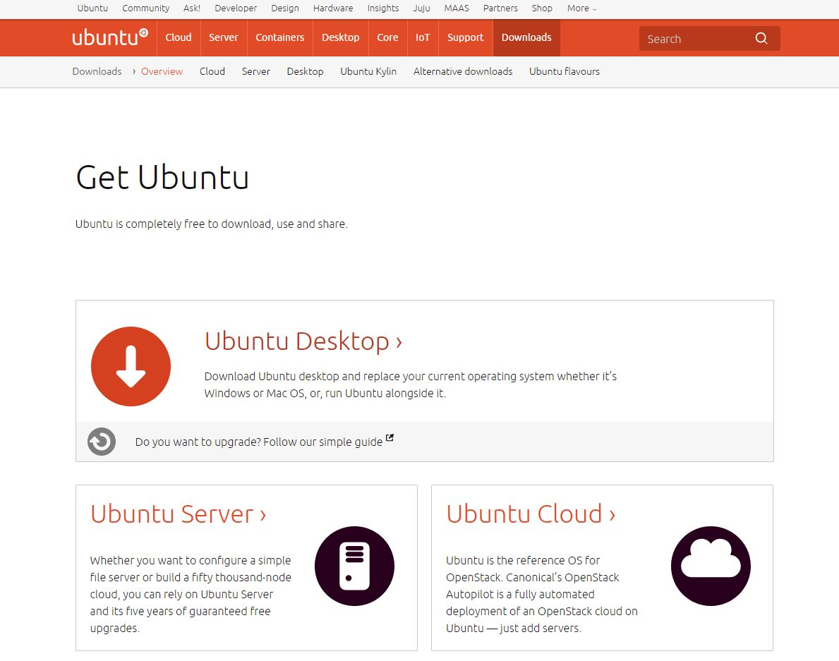

Click here to proceed to step b

Figure .1: Ubuntu downloads page

1. Selecting the correct distribution version: After clicking on the “Desktop” link, you will be brought to a page like the page seen in figure 1.2. On this page, you are given the option to download two different ISO files, one that is older but more stable, and one that is newer but less stable. For this instruction set, we will be using Ubuntu 13.04.3 LTS because it has been more thoroughly tested and patched than Ubuntu 17.04, and thus is less prone to potential bugs or system errors.

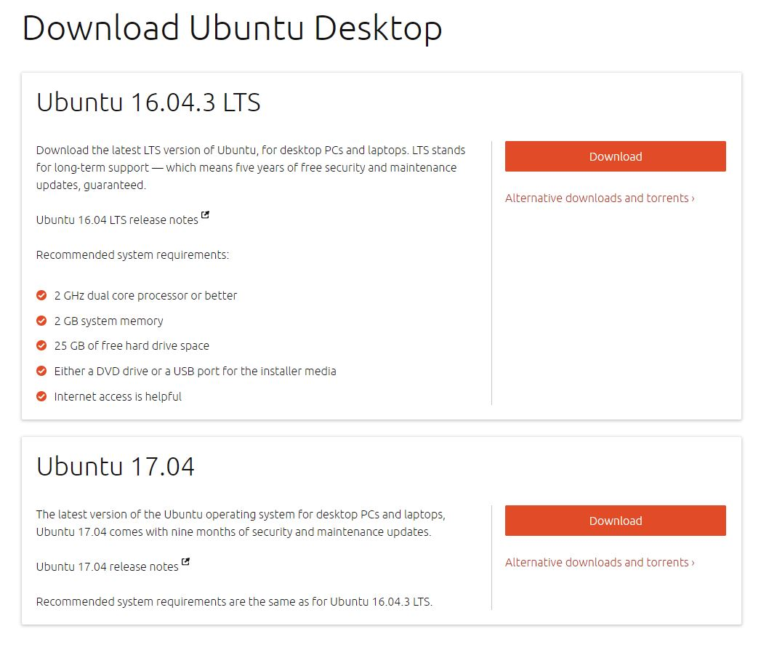

Click here to download Ubuntu 16.04.3 LTS

Figure 1.2: Selecting Ubuntu distributions. We will be using Ubuntu 16.04.3 LTS

1. Donating (or not) to Ubuntu developers: You will need to click on the “Download” button for Ubuntu 16.04.3 LTS, as seen in figure 1.2. After clicking this button, you will be brought to a page to make an optional contribution to the developers that help maintain and iterate on Ubuntu. If you would like to donate, fill in the amount you would like to donate in the appropriate boxes (as seen in figure 1.3), and then click on the “Pay with PayPal” (as seen in figure 1.4). If you would like to skip the donation, you can click on the “Not now, take me to the download” link (as seen in figure 1.4).

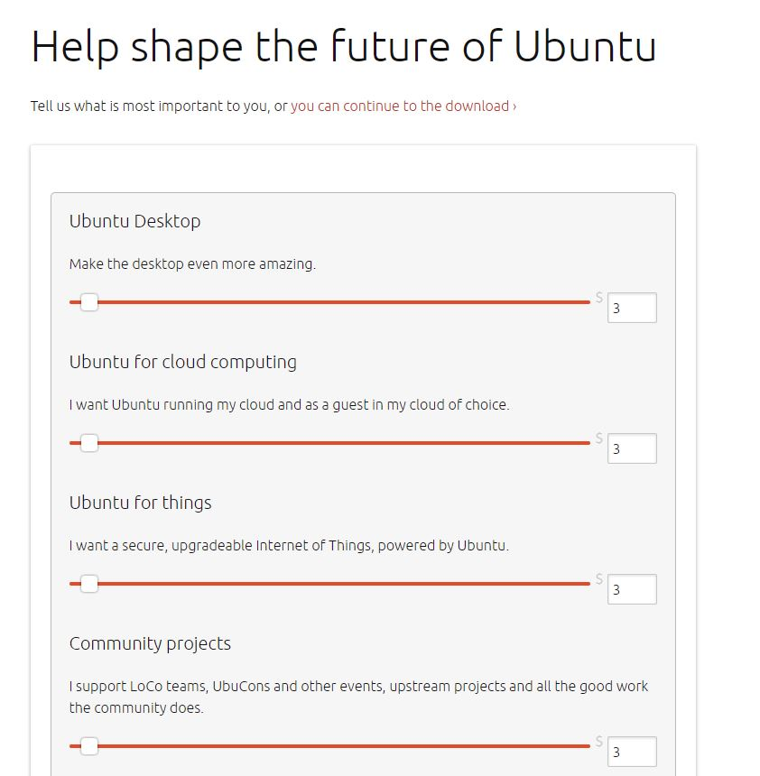

Figure 1.3: Making a donation to the developers

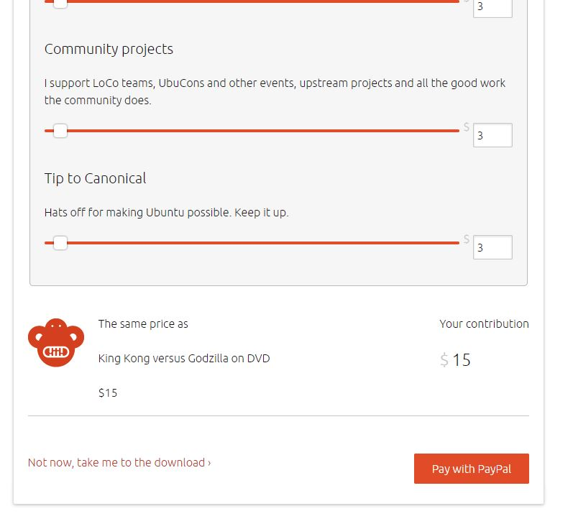

Enter the amount you wish to donate, if any, into these boxes

Click here to donate to the developers using a PayPal account

Click here to skip donating and proceed to the download

Figure 1.4: Skipping the donation, or making a donation

1. Downloading Ubuntu: Finally, you should have reached the point where you can download the ISO file. Your browser should automatically begin downloading the ISO file after taking you to the webpage seen in figure 1.5. Because of how large this file is, it can take some time before it is complete. While it is downloading, you can move on to step 2.

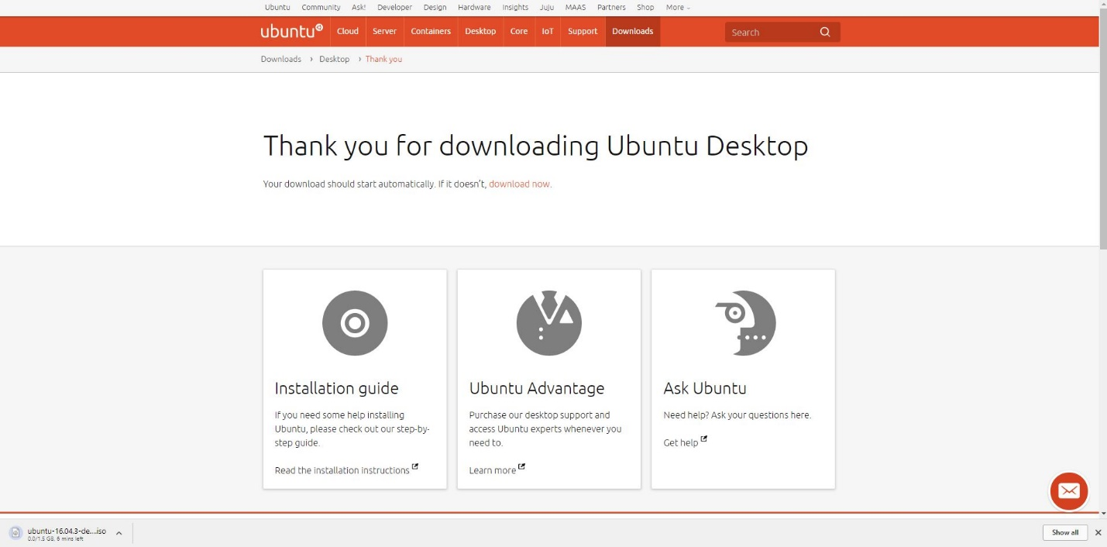

Figure 1.5: Finally downloading the ISO file

Step 2: Downloading and Running Rufus

1. Navigating to the Rufus webpage and downloading Rufus: To download Rufus, you will need to navigate to the Rufus webpage (<https://rufus.akeo.ie/>). After navigating to this webpage, click on the “Rufus 2.17” link shown in figure 2.1.

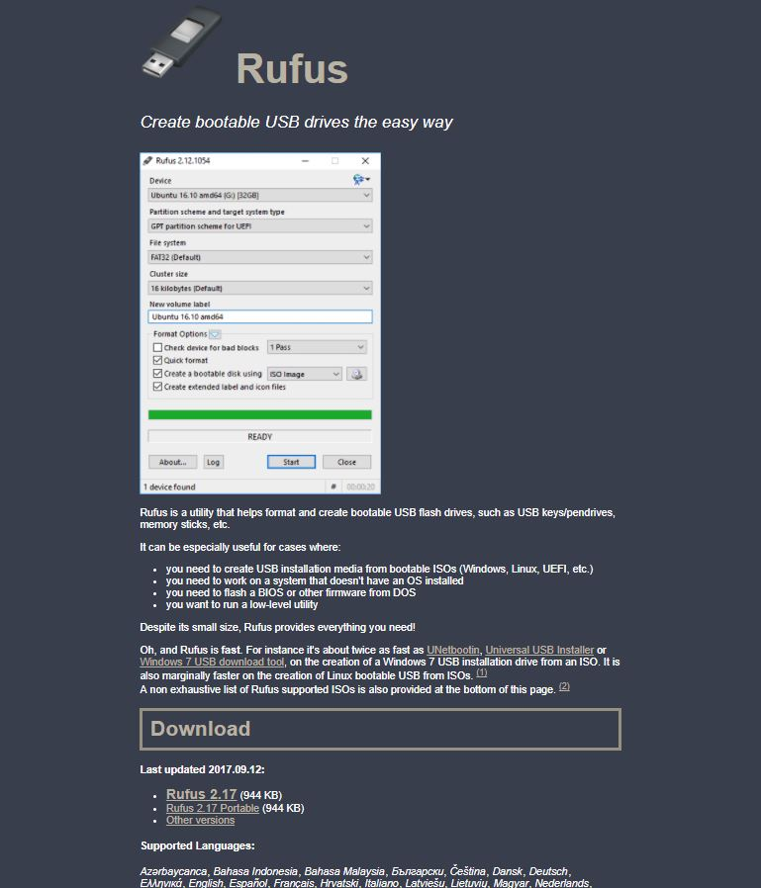

Click here to download Rufus

Figure .1: Rufus webpage



Figure 2.2: Rufus download link

1. Running Rufus: Clicking on the download will begin running Rufus. You can find your Rufus executable file download in your “Downloads” folder. After clicking on the executable, a new window will open on your desktop. This new window will be similar in appearance to figure 2.2.

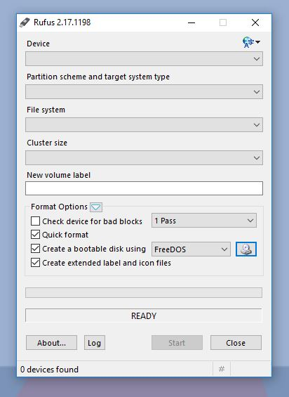

Figure 2.2: This is what Rufus should look like upon running it

Step 3: Formatting Your Flash Drive

1. 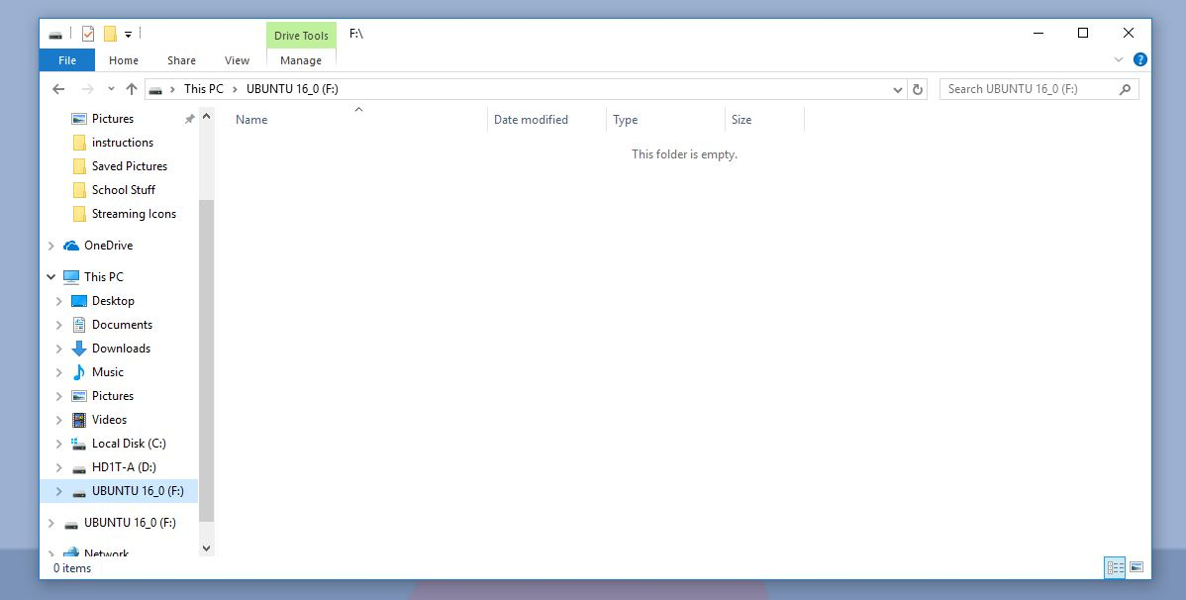Insert your flash drive into your computer: Insert your flash drive that you wish to format into your computer. After it is inserted, check the name of the drive using the File Explorer (see Figure 3.1).

Your flash drive should appear in this box, most likely near the bottom. Most often, flash drives will be listed as (F) drives, but not always. I have renamed my drive “UBUNTU 16_0” so as to avoid future confusion.

Figure .1: Finding your drive name in the File Explorer

**Tip:** Before inserting your flash drive into your computer, remove all unnecessary peripherals that are plugged into your computer! This will prevent selecting the wrong peripheral and thus prevent overwriting the formatting on your other drives / peripherals.

1. 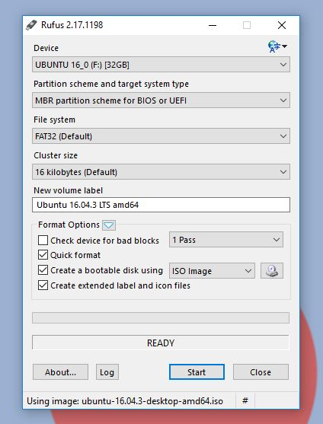Setup Rufus for formatting: With Rufus running, select the correct options from the drop-down menus within. The correct options are as follows (see Figure 3.2 and 3.3 as well):

This is where you will select the downloaded ISO file (click on the image of the disk)

You will need to ensure that “Device” and “Partition scheme and target system type” are selected correctly

Figure 3.2: Setting up Rufus for formatting

* 1. Device: This will be the flash drive you have inserted. If you removed all other drives / peripherals, your flash drive should be the only option available to choose. If there are other devices listed, choose your flash drive (see Step 3 Part a).

**Warning:** It is imperative that you select the correct drive on this step. Selecting the incorrect drive will reformat a drive, deleting all its data and replacing it with the Ubuntu ISO image. See Step 3 Part a for tips on how to mitigate the risk of selecting the wrong drive.

* 1. Partition Scheme and Target System Type: If you intend on using your Ubuntu USB with a new computer (2010 or later), select “MBR partition scheme for UEFI”. If you plan on using the drive with an older computer (2009 or earlier), select “MBR partition scheme for BIOS and UEFI”.
  2. Create a bootable disk using: Next to this check box, you will click on the image of the disk, and select the ISO file that we downloaded earlier (see Figure 3.3).

1. Start the format: Click on “Start” to begin formatting your flash drive. You might a popup asking if you would like to create a hybrid ISO image. Keep “Write in ISO Image mode (Recommended)” selected, and click “OK” (see Figure 3.4). You will also receive a warning from Rufus stating that formatting the flash drive will completely wipe 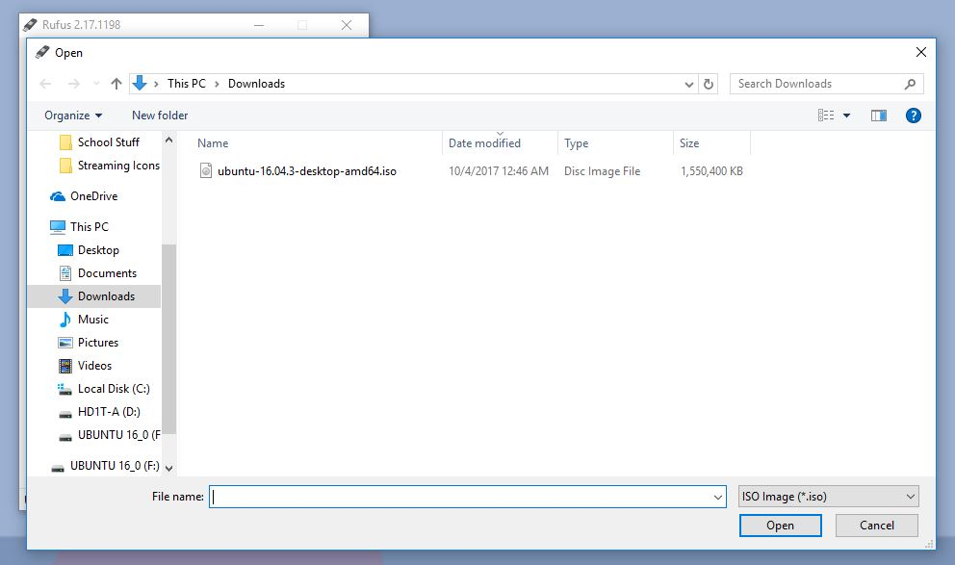everything that is currently on the flash drive. The format should take ~5 minutes.

After selecting the ISO file, click “Open”

Figure 3.3: Selecting the ISO file

The ISO file should look similar to this, and can be found in your “Downloads” folder

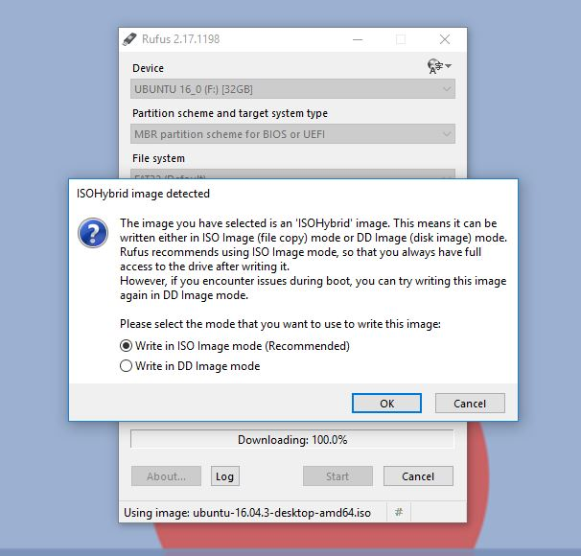

Keep the first option selected, and click “OK” to continue with the format

Figure 3.4: ISO Hybrid Image

Step 4: Booting into Ubuntu from the Flash Drive

1. Restart your computer with the USB still inserted: Most computers will automatically boot into an ISO USB if it is connected. You can either restart your computer or shut down and power back on your computer to do this. If your computer does not boot into Ubuntu automatically, you will need to manually boot into your connected USB. You can do this by holding the *shift* key while clicking “Restart”. This will open your restart options. From there, click on “Use a Device”, and then select inserted USB drive (See Figure 4.1). After selecting your drive, your computer will automatically restart and boot into your USB.

Figure .1: Restarting and booting from USB

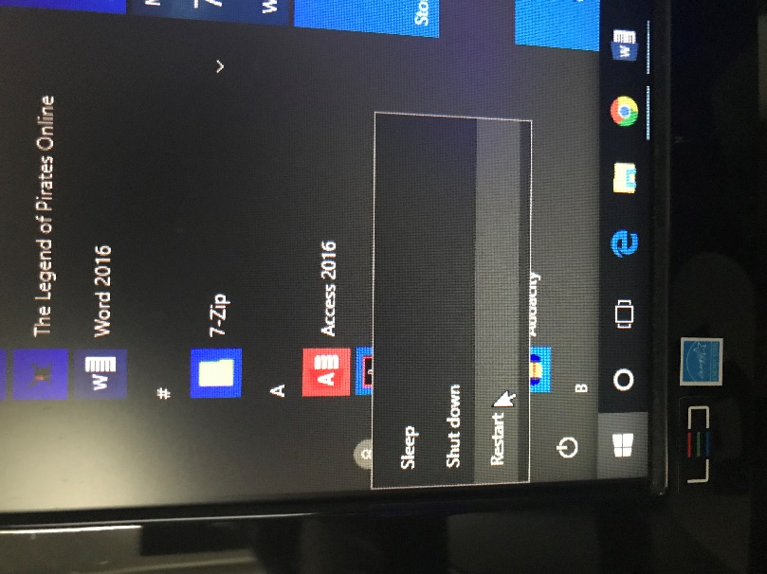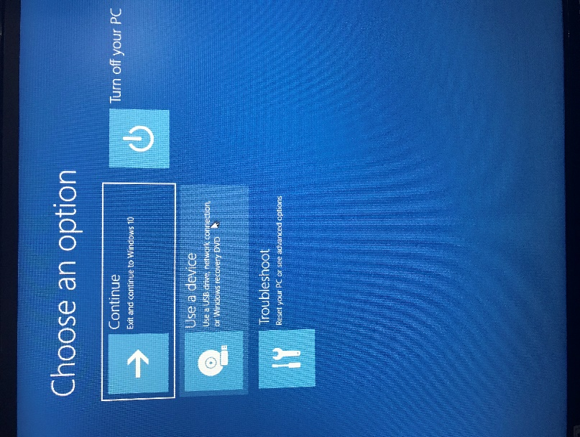

1. Installing / Trying Ubuntu: After booting into Ubuntu, you will be walked through an installation process. During this process, you will have the option of wiping and installing Ubuntu onto your hard drive, reformatting your hard drive to dual boot Ubuntu and Windows, or trying out Ubuntu without installing. Helpful tips on the various ways to setup Ubuntu on your device are not covered in this instruction set, but can be found here: <https://tutorials.ubuntu.com/tutorial/tutorial-install-ubuntu-desktop#0>

Troubleshooting Steps:

1. Download required when reformatting flash drive: When formatting your flash drive using Rufus, after clicking on “start” to begin formatting, Rufus may prompt you that there are certain files necessary for the ISO image to work that aren’t present. An image of this is seen in Figure 5.1. If you experience this prompt, simply click “Yes” on the popup to continue with the formatting.

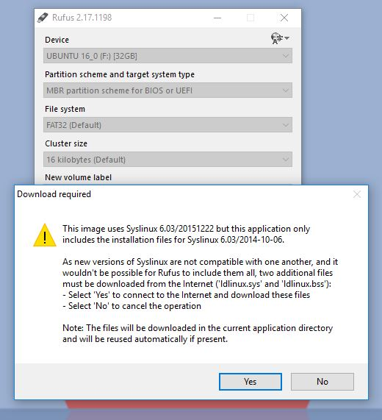

Figure .1: Download required prompt

1. Trouble booting into the USB: If you experience issues booting into your connected flash drive, you may need to configure your BIOS to force your computer to boot into your USB. Unfortunately, due to the wide variety of computer manufacturers, there are multiple different ways to configure your BIOS to boot into USB. I would recommend looking up at your computer’s manufacturer’s website on how to configure your BIOS to boot into USB, or use the user manual provided when purchasing your computer. Most often, to access the BIOS on computers, when turning on your computer you will need to tap either the f2, f3, f10, or f12 key. Look into your manufacturer’s website or the user manual provided with your computer to be sure.

Glossary:

1. ISO File: Also called an ISO image, ISO files are single files that are essentially a perfect copy of a CD / DVD in file form. All aspects of a CD / DVD are duplicated in an ISO file. ISO files are most often used for operating systems, because they are able to compact all of the code found in operating systems into a single file that can be downloaded over the internet rather than needing a physical CD.
2. BIOS: Also known as “Basic Input Output System”, BIOS is the base level interface of your computer. It is a graphical interface that allows users to configure various aspects of their computer’s hardware and boot settings, and comes pre-installed on computer motherboards. Most often, when you turn on your computer it will skip over opening the BIOS options and boot strait into your operating system. You can access your BIOS in various ways, although most often by pressing one of the function keys on your computer when booting up your computer.
3. MBR Partition Scheme: Also known as “Master Boot Record” Partition Scheme, this is a specific boot sector located at the beginning of a drive and contains a boot loader for the operating system installed alongside it. The boot loader is a small block of code that initiates the boot of the operating system.
4. UEFI: Also known as “Unified Extensible Firmware Interface”, UEFI is a specification for a software program that connects a computer’s firmware to its operating system. UEFI is, in essence, a more modern version of BIOS.
5. More on Ubuntu: More information on Ubuntu, and to access the huge Linux community for help, updates, and news, head over to <https://www.ubuntu.com/>

SME: Eric Morales

OU IT Service Specialist

“Overall these instructions are pretty good. I think you should definitely add a little more emphasis on the warnings for formatting the flash drive, just to make sure that you don’t accidently reformat a drive that you’re not supposed to. Other than that, pretty good.”